*Firmware Upgrade*

***Company programming software will not recognize TD-H3 unless you upgrade the firmware***

(Do not turn on the radio untill step6)

Step1 Install Firmware Upgrade Software

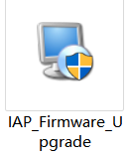

Step2 Open ***IAP_3773_3782***

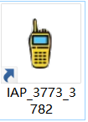

Step3 Connect your radio with a **programming cable, choice corresponding port.**

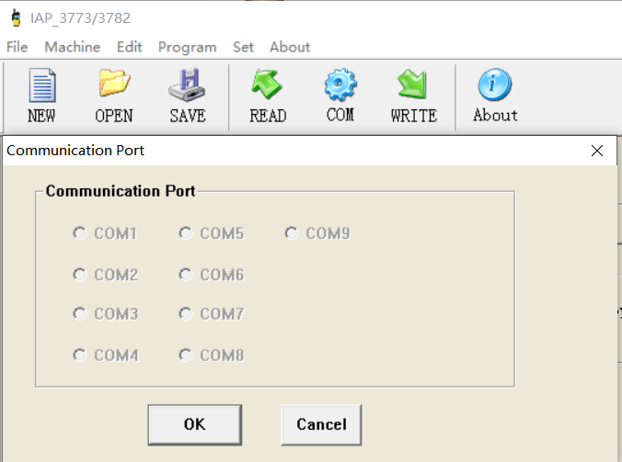

Step4 Click **[OpenFile]** and then select the firmware upgrade file

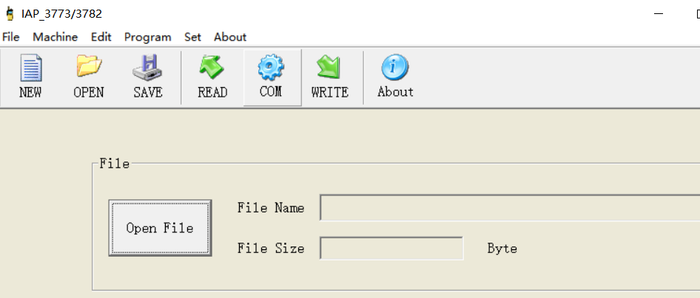



Step5 Press the upper part of the cable kenwood jack through out the upgrade process.

Step6 Click **[Start]** and then **Press PPT+** **turn on** your radio

***\*There will be a progress bar to indicate the progress of the software when the upgrade starts correctly.\****

***Q1: What should i do if there are not progress bar after I turn on my radio***

***A1: Hold the plug of the programming cable tightly during the upgrade and do it again, never loose the grip.***

***Q2: What should i do if the upgrade fail and the radio cant turn on again.***

***A2:Because the upgrade process may be interrupted, resulting in an incomplete version upgrade of the radio. You need to repeat the upgrade steps again to completely accomplish the upgrade.***

***More question please email suppport@tidradio.com***